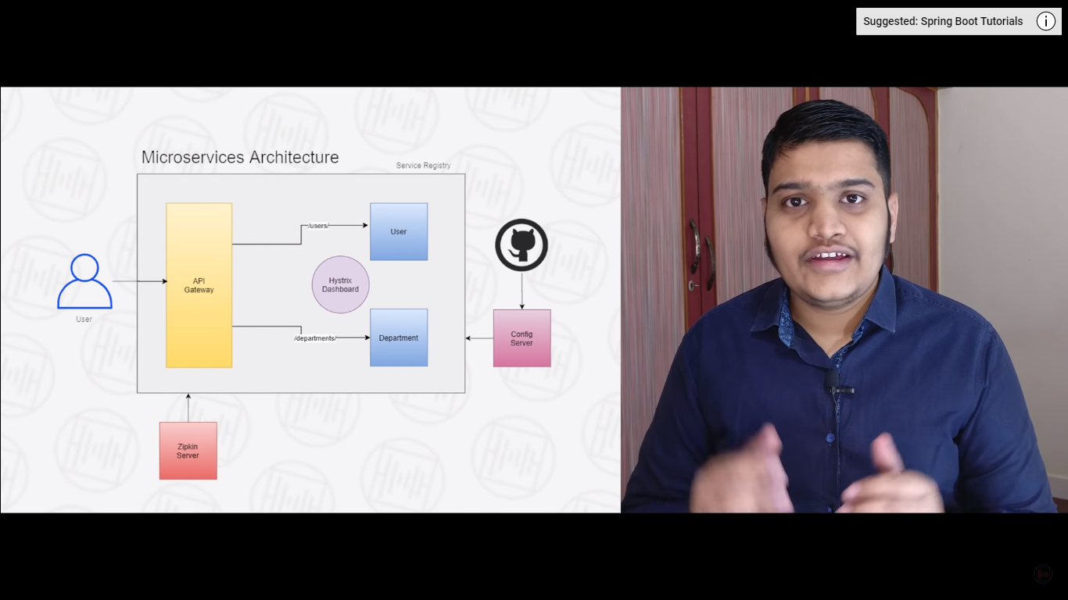

Zipkin configuration:

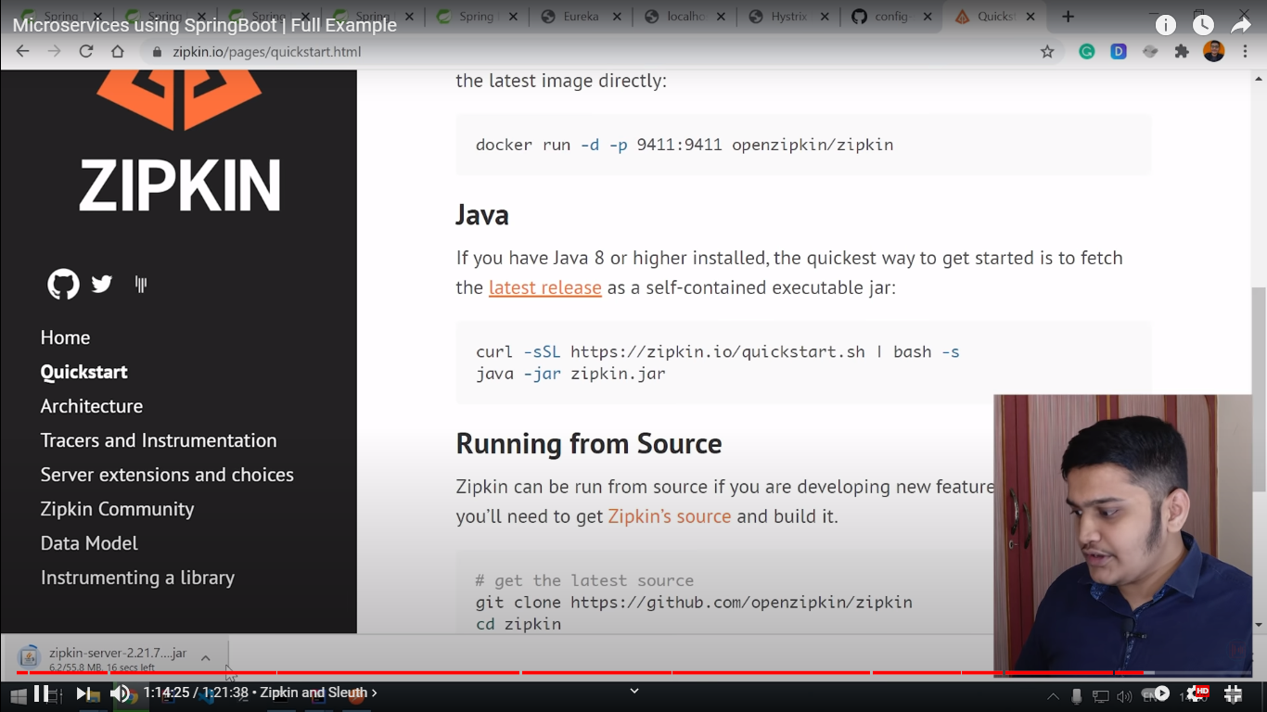

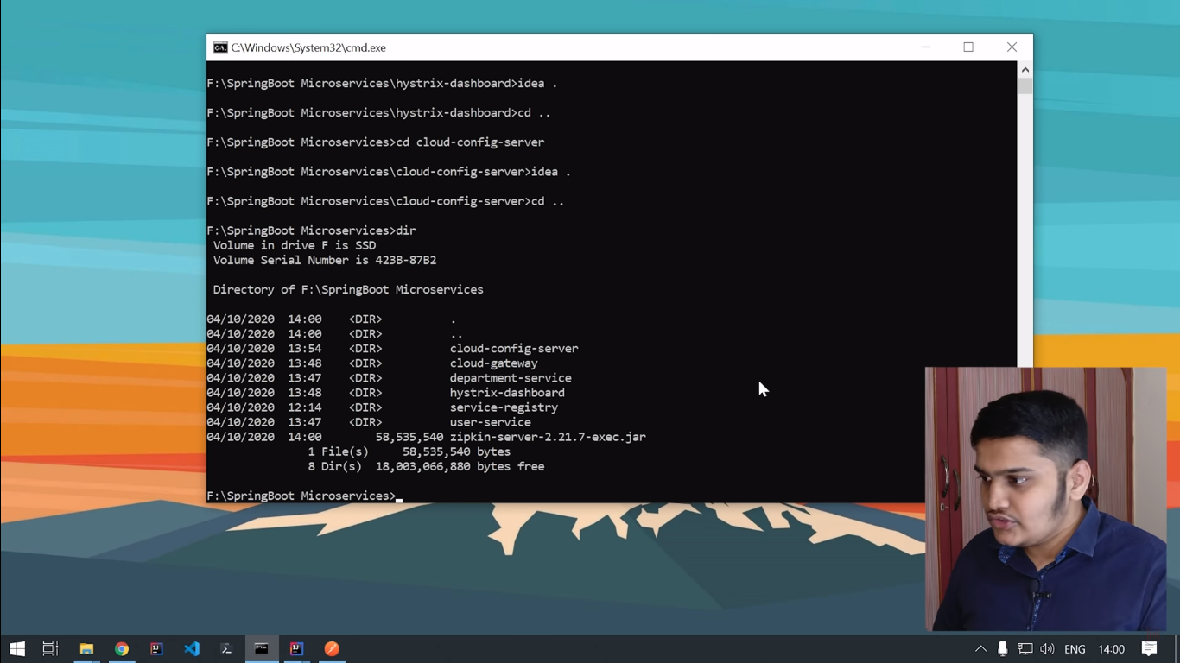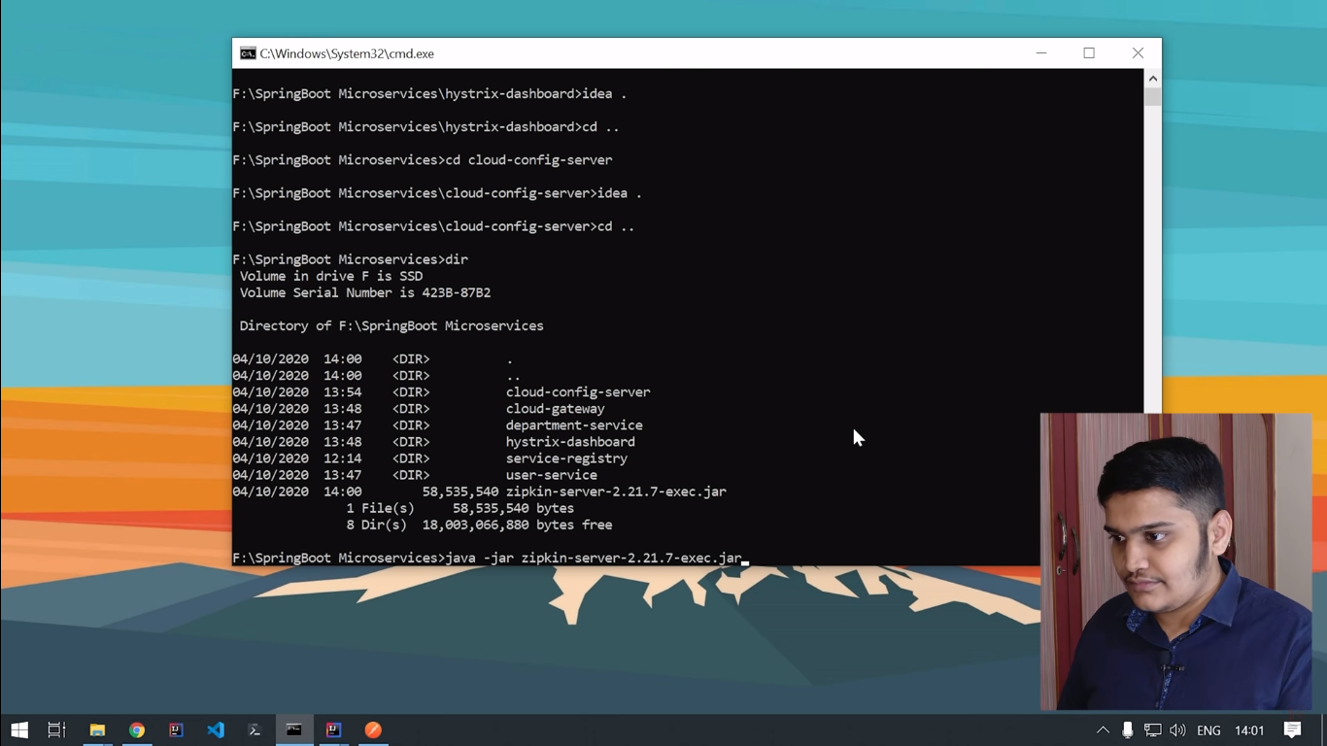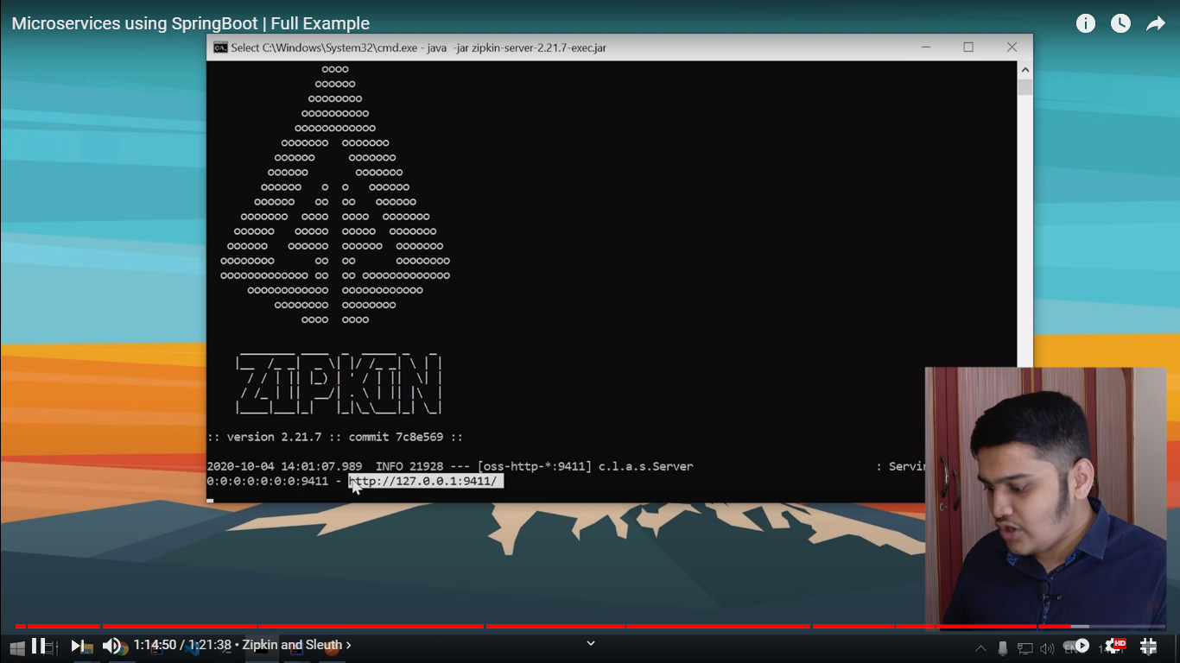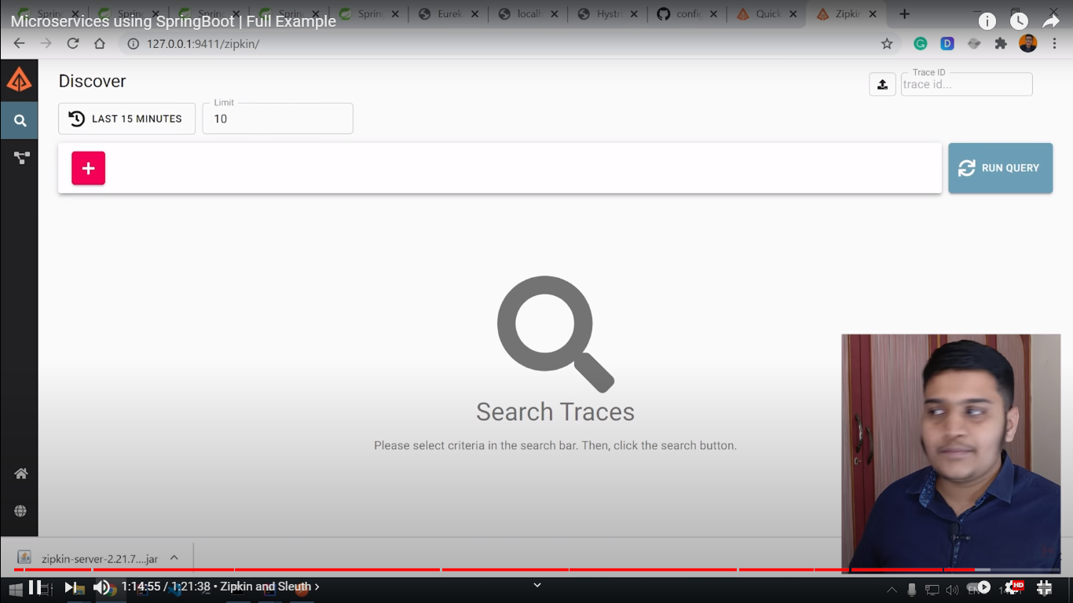

**Add the dependencies to User and Department services:**

<dependency>

<groupId>org.springframework.cloud</groupId>

<artifactId>spring-cloud-sleuth-zipkin</artifactId>

</dependency>

<dependency>

<groupId>org.springframework.cloud</groupId>

<artifactId>spring-cloud-starter-sleuth</artifactId>

</dependency>

Add below to yml file:

zipkin:

base-url: http://127.0.0.1:9411/

